**PRIEKUĻU NOVADA PAŠVALDĪBA**

[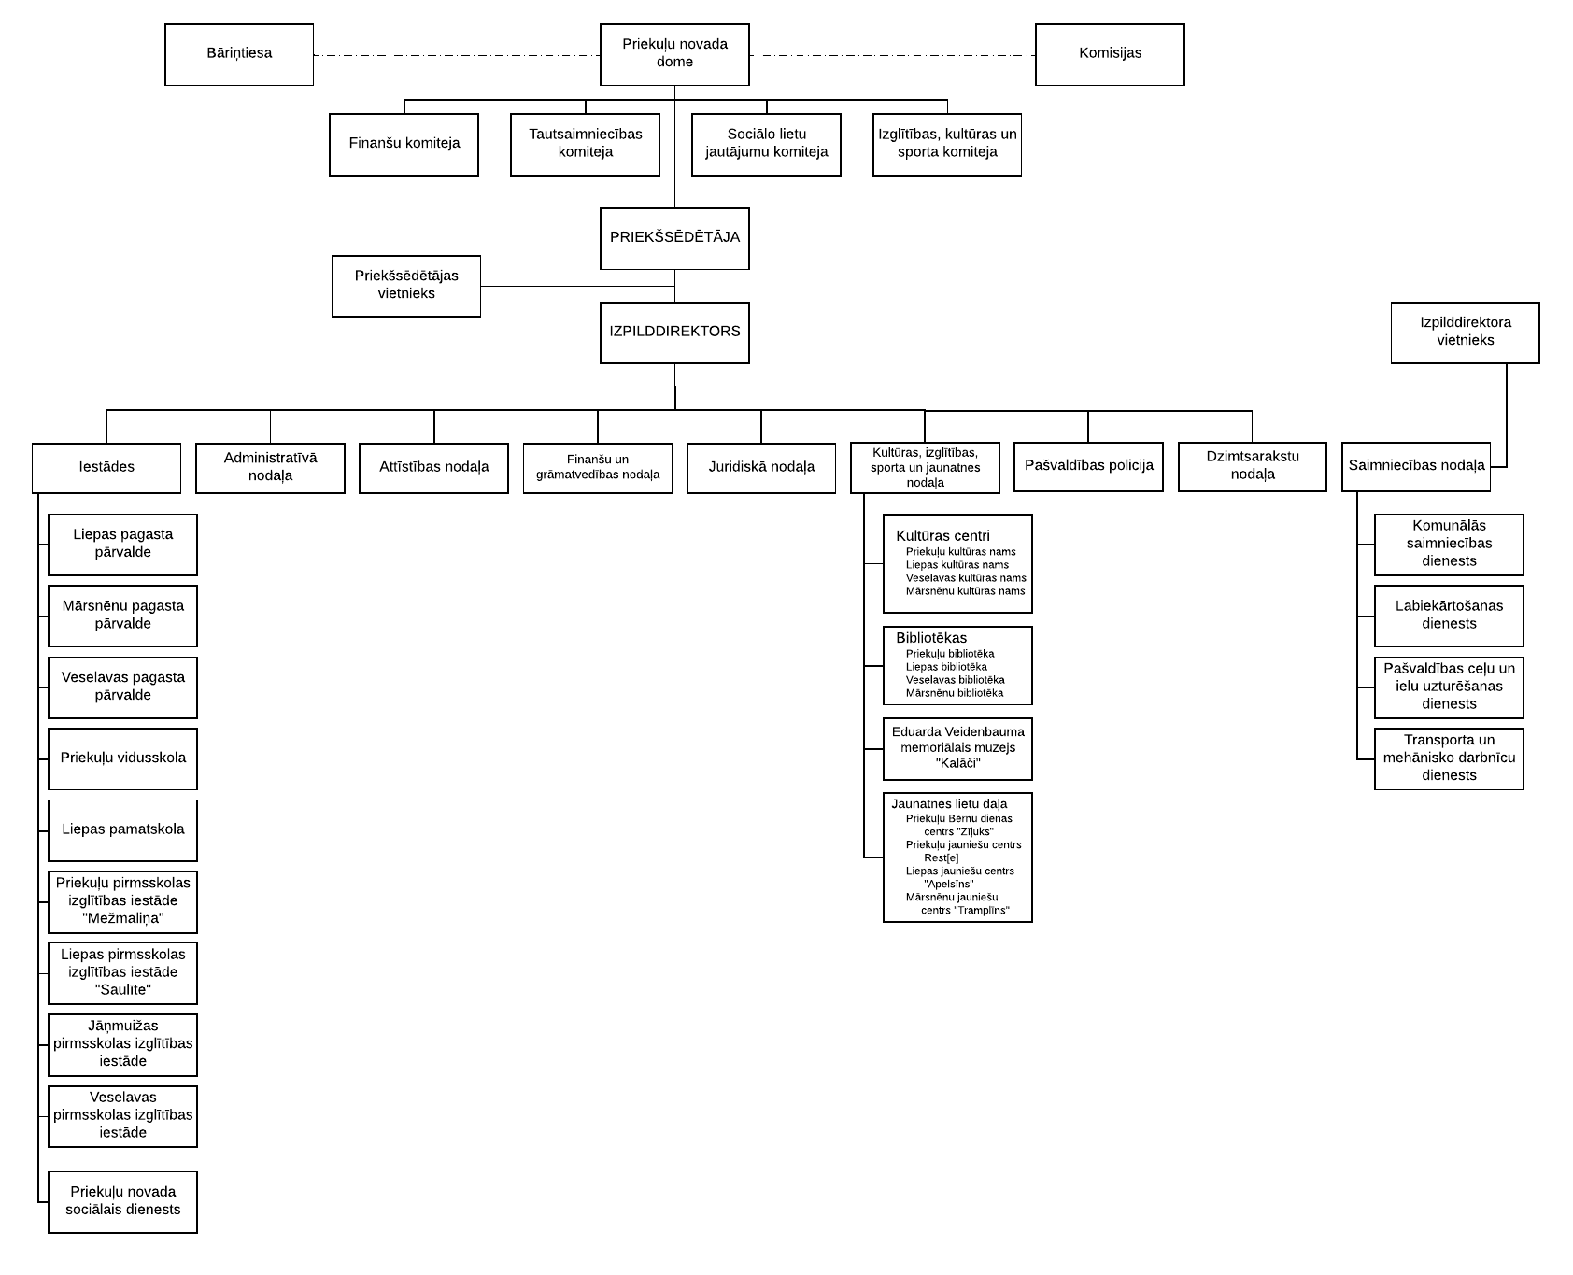](https://www.lucidchart.com/documents/edit/f533cbdf-44e6-4214-a417-0983189f8cc8/0?callback=close&name=docs&callback_type=back&v=1910&s=841.8897637795277)